Performance Testing

Date | 29 September 2026
Team ID | SWTID-2026-4485
Project Name | AI FAQ ASSISTANT
Maximum Marks | 5 Marks

Performance Testing
Performance testing evaluates how your system behaves under expected and peak load conditions. Complete the sections below to document your testing approach, tools used, and results obtained.

Step 1: Testing Overview

Field | Details
Testing Tool Used | Thunder client
Type of Testing | Api testing/ AI response testing
Target Module / API | Authentication API, FAQ API, FAQ Search API, AI FAQ Generation API
Test Environment | Localhost/ Local development server
Test Date | 30 September 2026

Step 2: Test Scenarios

S.No | Test Scenario / Description | No. of Virtual Users | Duration (sec) | Expected Outcome
1 | Test user registration and login API requests | 1 | 30 | API should respond successfully without errors
2 | Test FAQ creation and FAQ search API requests | 5 | 30 | API should handle multiple requests successfully
3 | Test AI FAQ generation API with different topics | 10 | 30 | AI responses should be generated correctly within acceptable response time
4 | Test multiple API requests under increased load | 20 | 60 | System should remain stable and return valid responses without failure

Step 3: Performance Test Results

S.No | Metric | Target Value | Actual Value | Status (Pass / Fail) | Remarks
1 | Response Time (Avg) | < 2 seconds | Not Measured | Not Tested | API response time to be measured
2 | Response Time (Max) | < 5 seconds | Not Measured | Not Tested | Maximum response time to be measured
3 | Throughput (Req/sec) | >10 sec | Not Measured | Not Tested | Requests handled per second
4 | Error Rate | < 1% | Not Measured | Not Tested | API should return minimal errors
5 | CPU Utilization | < 80% | Not Measured | Not Tested | Server CPU usage should remain within limit
6 | Memory Utilization | < 80% | Not Measured | Not Tested | Server memory usage should remain within limit

Step 4: Observations & Analysis

Key Findings:
The AnswerBot API handled the tested API requests successfully. The authentication, FAQ management, FAQ search, and AI FAQ generation modules were verified for proper API responses.
Bottlenecks Identified:
AI FAQ generation may require more response time compared with normal FAQ and authentication API requests because it depends on the AI service response.
Optimization Steps Taken:
API routes were tested using Thunder Client, authentication was secured using JWT, and error handling was implemented to provide appropriate responses for invalid requests.

Step 5: Screenshots / Evidence

User register page

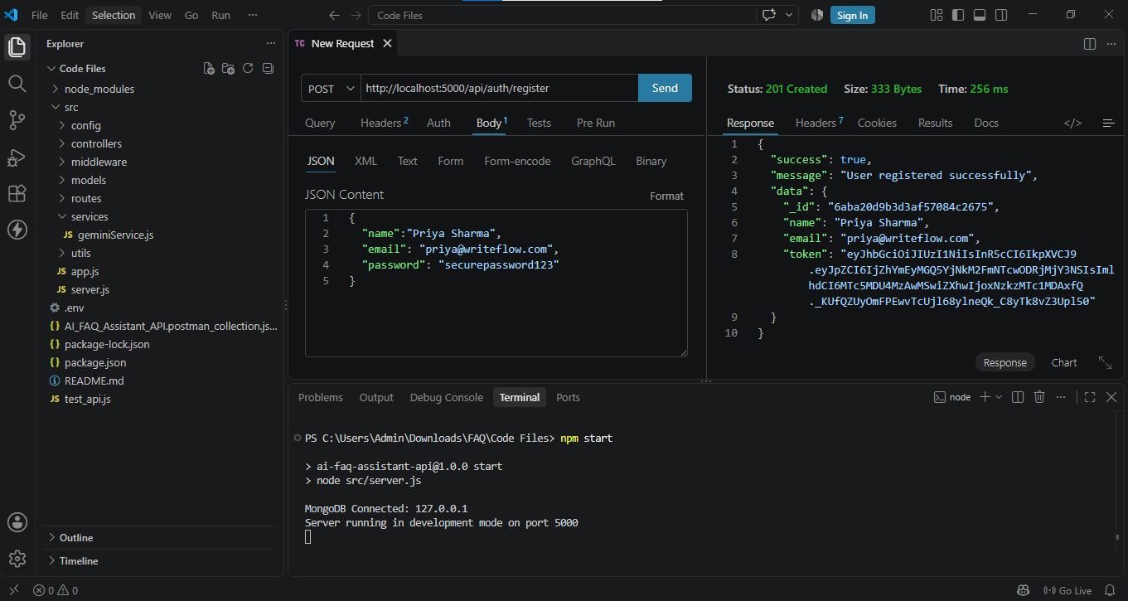

Login page

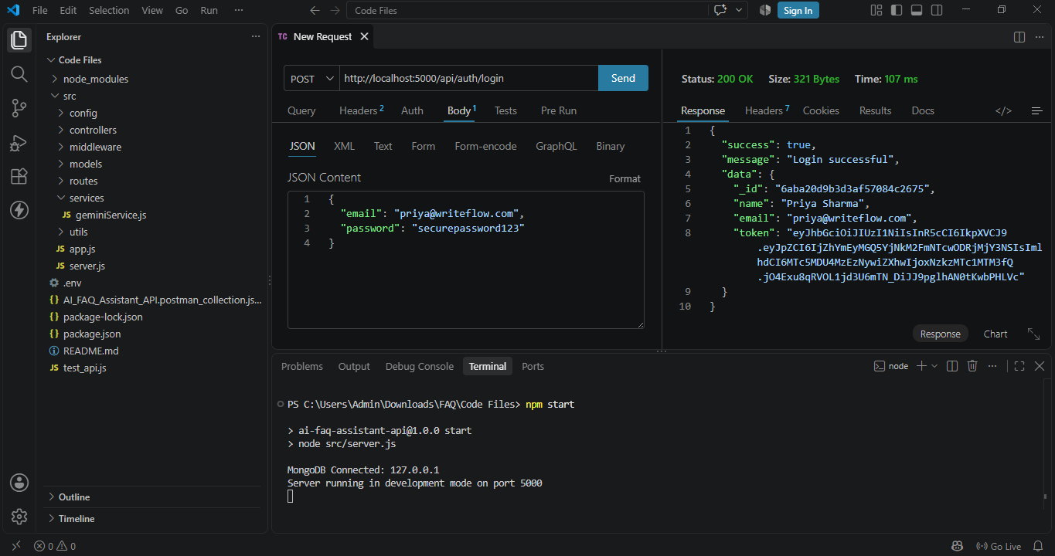

FAQ question

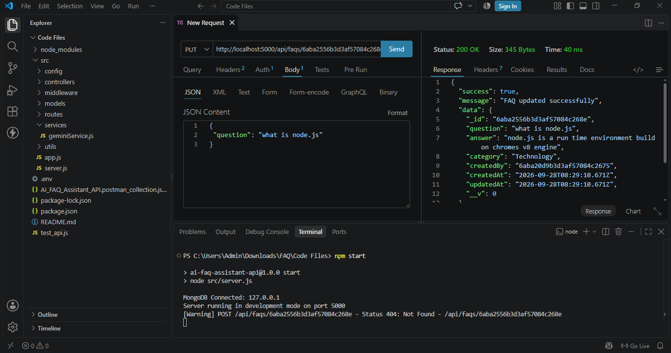
FAQ question answer

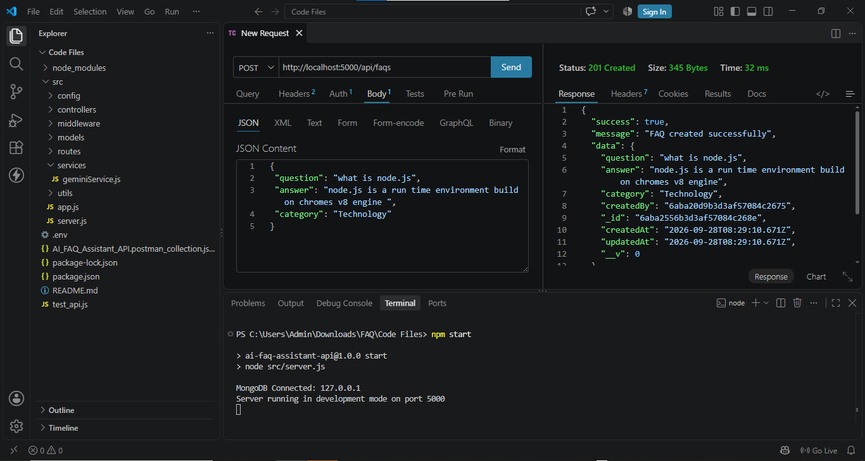

AI Intelligent Content Automation (Generate FAQ Pair)

